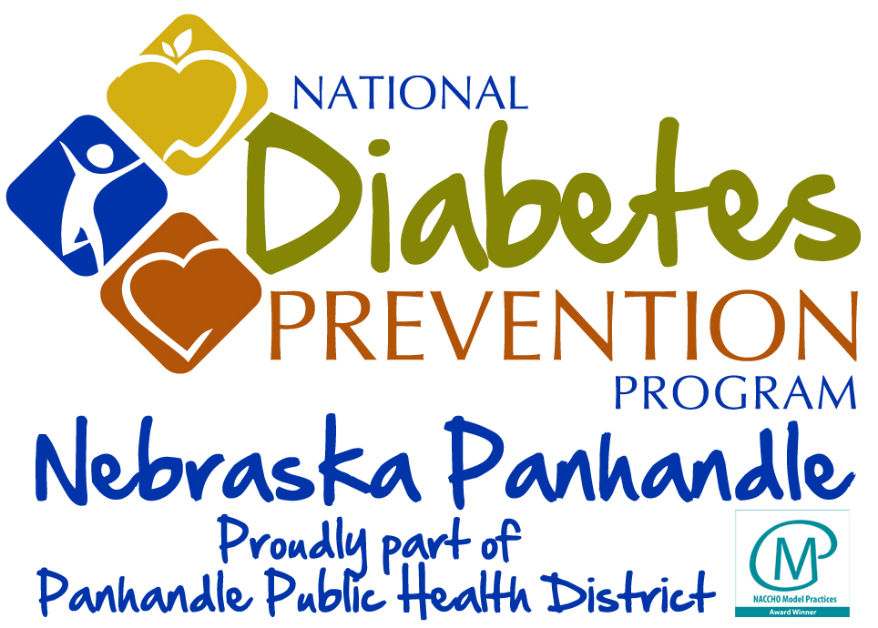

(Date)
Dear

I am a participant of the National Diabetes Prevention Program (National DPP) in [Location]. We have worked for the past year with trained Lifestyle Coach, {Your Name}, in order to learn the skills needed to make lasting lifestyle changes.

The primary goals for the program are:
- to achieve and maintain a weight loss of 5-7% of their initial body weight, and
- to achieve and maintain at least 150 minutes of moderate physical activity per week.
Below is a brief outline reflecting my progress.
Starting Weight (lbs): ________ Current Weight: _________
Blood Pressure: __________
Physical Activity (average minutes per week): ____________

Thank you for referring to the National DPP.

Yours sincerely,

